

Lyng Primary School Knowledge Organiser

Information Technology



Summer 2

Weather forecast

Year 4

Topic: IT

|  |  |
| --- | --- |
| What Goldilocks and Step On words will I use? | |
| **Spelling** | **Defintion** |
| Algorithm | A sequence of instructions which, when followed, solve a problem. |
| Automated machine | Works without the need for human interaction, after being programmed to carry out a specific job. |
| Forecast | To predict what might happen or occur as the result of something in the future. |
| Log Data | The outcome in written or digital form or informal results that need to be collected. |
| Sensor | A tool or device that is designed to monitor, detect and respond to changes for a specific purpose, such as an alarm which will ring if smoke is detected in the room. |
| Source | Somewhere or someone with which information or materials can be obtaine. |
| Spreadsheet | A file where you can input, sort and analyse data in a series of cells. Formula can be written to output mathematical solutions from the data. |
| Weather satellite | A form of satellite designed to monitor weather conditions. |



**Aims of this unit**

* Log data taken from online sources within a spreadsheet.
* Design a weather station.
* Design an automated machine to respond to sensor data.
* Understand how weather forecasts are made.
* Create a short video

**Safeguarding**

Filtering and monitoring system is in place. Children will use their own log in details to track any misuse and to protect the child from harmful websites and pop ups. Children will be reminded of how to stay safe online and to use technology safely and respectfully and to tell a trusted adult if there is anything on their computer that makes them uncomfortable. When using the iPads, the monitoring software will track which iPad has been used to enable us to know which class has used the iPad.

|  |
| --- |
| Outcomes |
| **All children**   * Explain how a weather station can record rain and temperature. * Input data into a spreadsheet. * Operate a camera during filming of a weather report.   **Most children**   * Search the web efficiently to find temperatures of different cities. * Design a weather station which gathers and records data. * Search for and record weather forecast information in a spreadsheet.   **Some children**   * Record accurate data about temperatures around the world and entering it in a spreadsheet. * Write an algorithm to explain how an automated device would work. * Explain how weather is predicted * Edit a video using chroma keying and explain how different colours can be used |

Summer Term 2

Weather forecasting

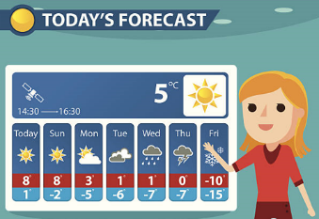

**In this unit…**

Children will look at how the weather is recorded around the world. They will identify how data is collected and presented. They will be designing their own weather station and will learn how weather stations help to predict extreme weather. The unit will end with the children creating their own weather forecast on green screen.

**Agreed outcome:**

A short video of a weather forecast.